1)Shell script program to add two numbers.
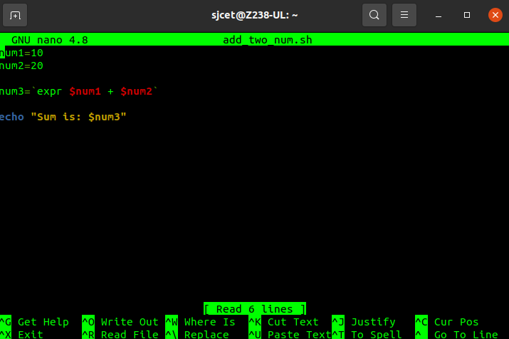

output:
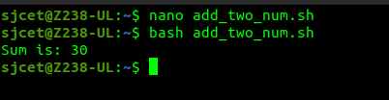

2)swap two numbers

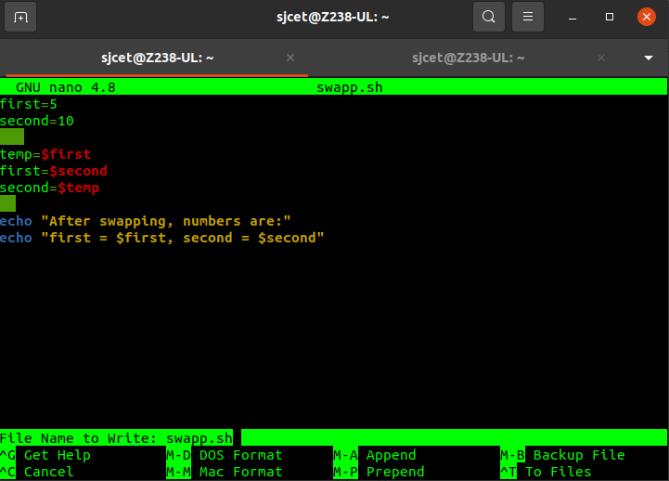

output:

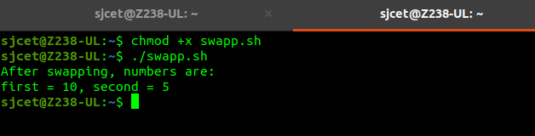

3)To perform ls command

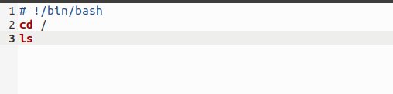

output:
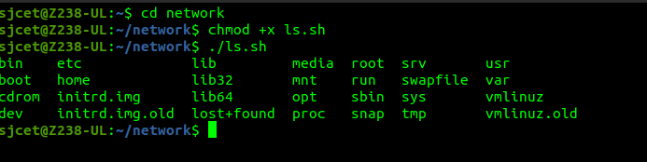

4)program to print the current process id ( $$ )

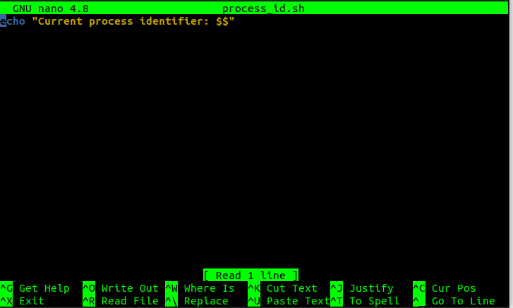

output:
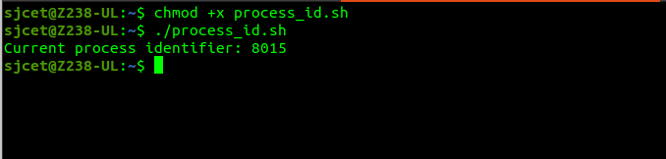

5)write a program to find the area and circumference of a circle

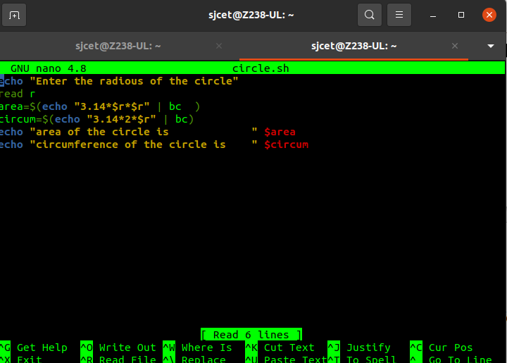

output:

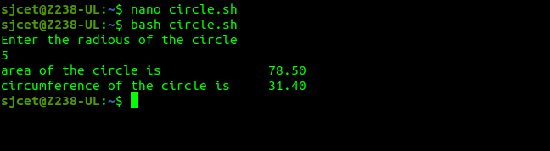

6) check whether the given number is prime or not

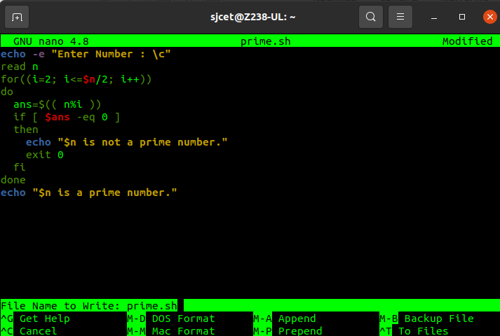
output:

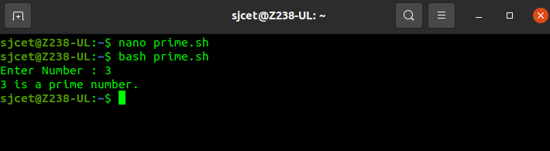

6)check whether the given number is odd or even

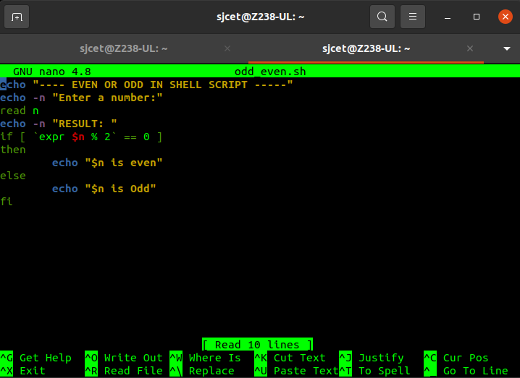

output:
